#SEWINTHISTOGETHER
Wallhanging
Created by, Denise Applegate-Schober
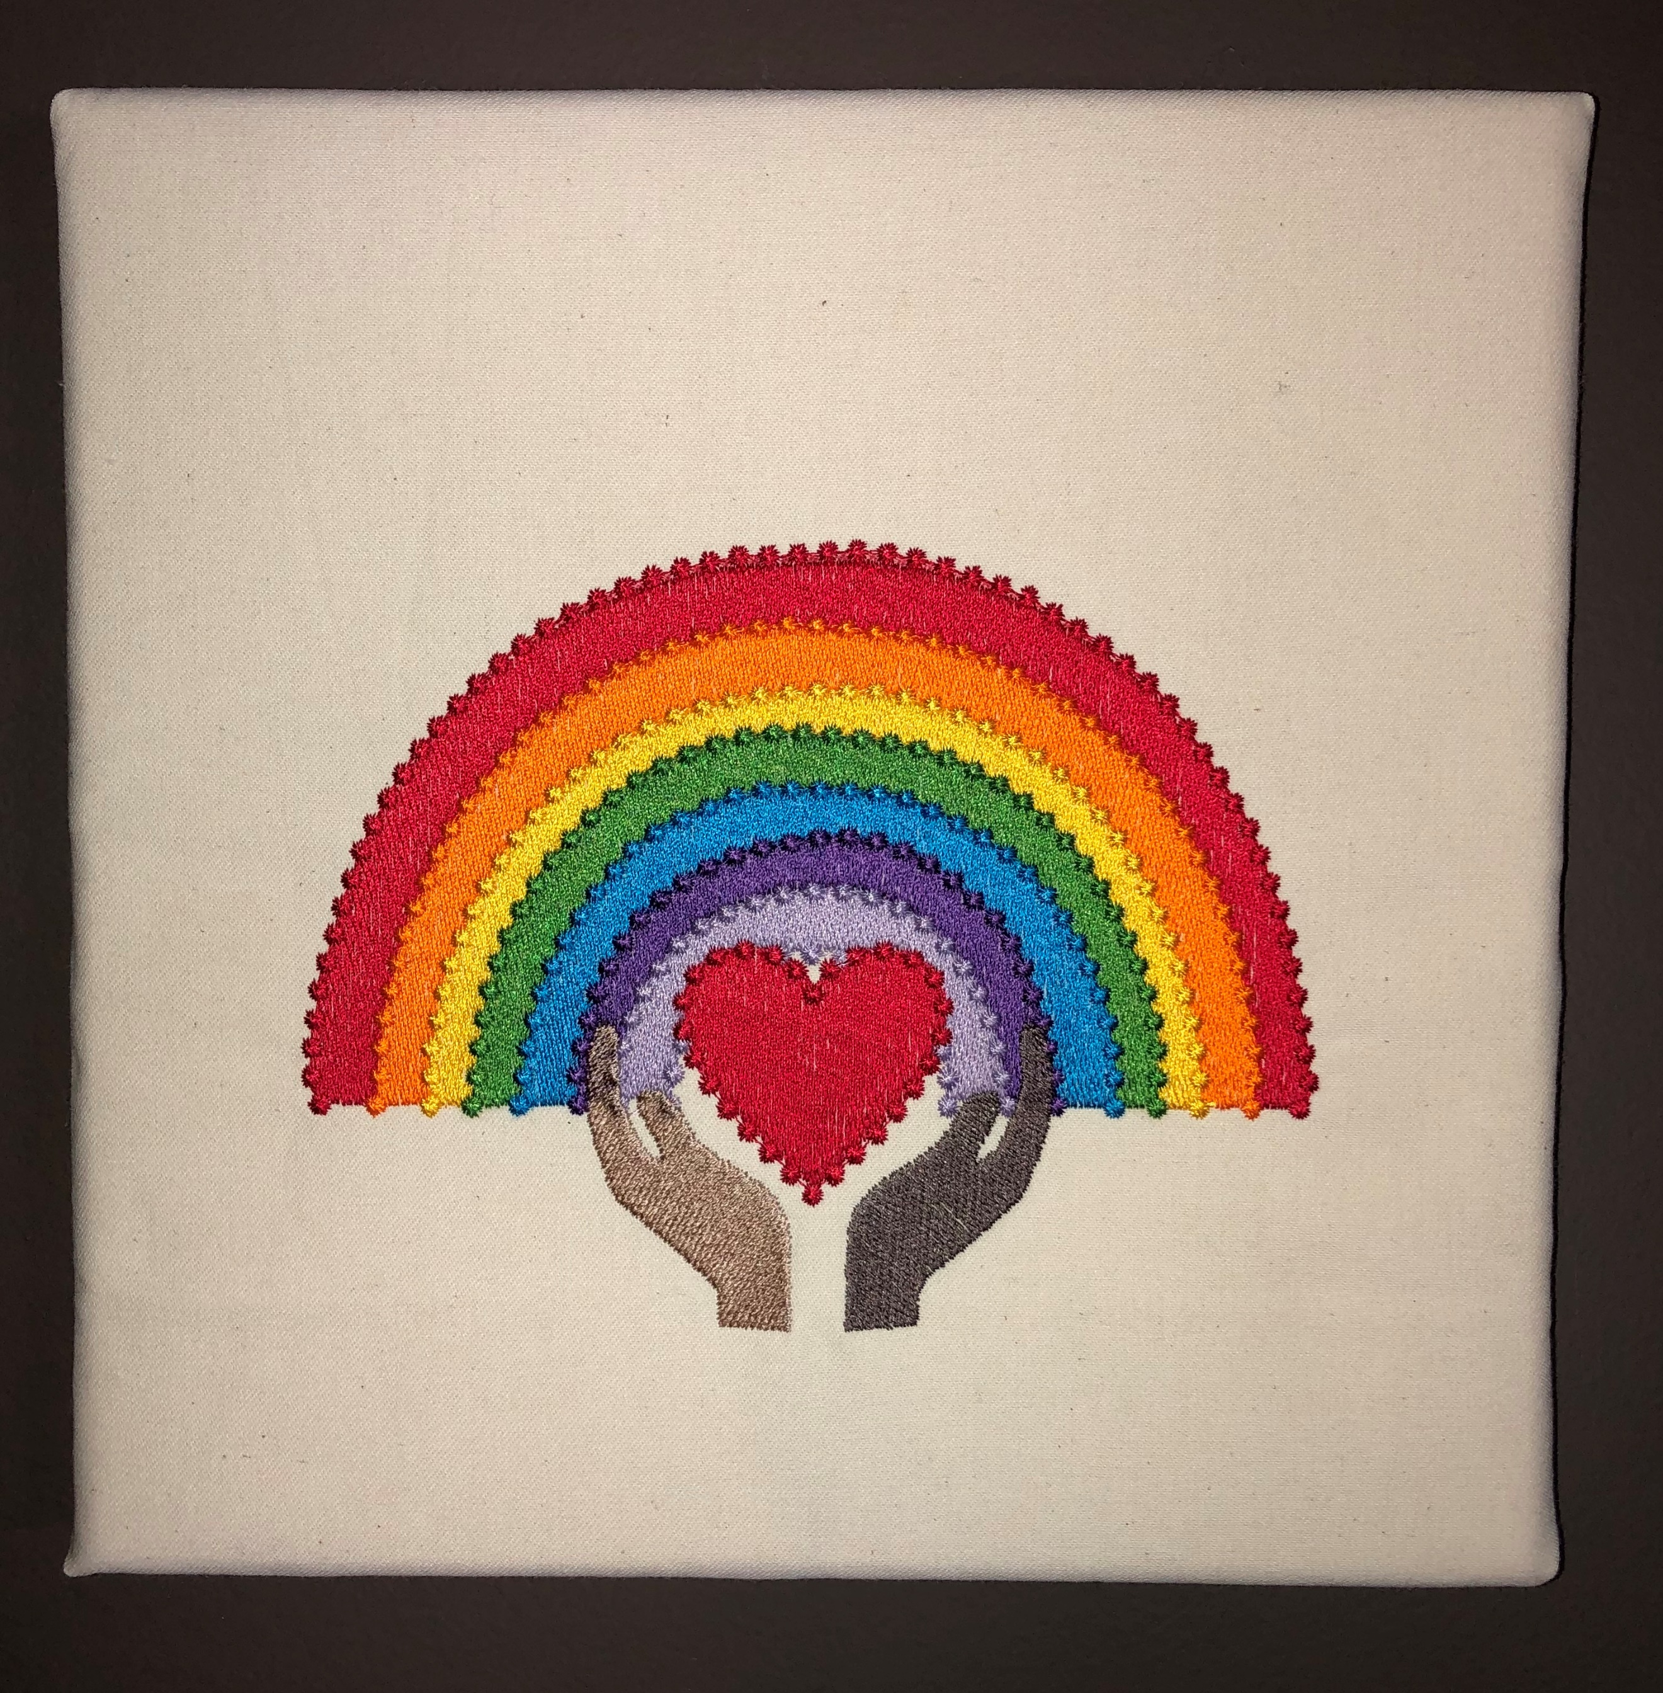
Supplies:
Quick Reference Guide
Canvas 24”x20
Ultra Soft Fusible Cutaway by Baby Lock
Assorted Threads
6 Pre-Wound Bobbins
10 5/8”x16” hoop
Snips
Mouse or stylist
Marking Pen
Stretch Bars or Art Canvas 8”x10”

- Open IQ Design Center
  - Click on Setting Pages
    - Click on page #8
    - Click on Arrow by Grid
      - Click on 3/8” grid
      - Click OK
  - Click on Shape Icon
  - Select ½ circle 3rd row 4th shape
  - Click OK
  - Click on Size Icon
    - Click on Reduce Inward/Condense Icon
    - *Resize Around .96”x1.76”
    - Click OK
  - Click on Duplicate Icon
    - Click on Size Icon
    - Click on Enlarge Outward/Expand Icon
    - *1.39”x2.56”
    - Click center button
    - Using up arrow move to align bottom edge line of two ½ circles
    - Use Zoom in and out as needed
    - Click OK
  - Click on Duplicate Icon
    - Click on Size Icon
    - *Resize 1.83”x3.36”
    - Click center button
    - Using up arrow move to align bottom edge line
    - Click OK
  - Click on Duplicate Icon
    - Click on Size Icon
    - *Resize 2.17”x3.98”
    - Click center button
    - Using up arrow move to align bottom edge line
    - Click OK
  - Click on Size Icon
    - *Resize 2.46”x 4.49”
    - Click OK
  - Click on Duplicate Icon
    - Click on Size Icon
    - *Resize 2.85”x5.02”
    - Click center button
    - Using right arrow move to align bottom edge line
    - Click OK
  - Click on Duplicate Icon
    - Click on Size Icon
    - *Resize 3.30”x5.77”
    - Click center button
    - Using up arrow move to align bottom edge line
    - Click OK
  - Click on Duplicate Icon
    - Click on Size Icon
    - *Resize 3.75”x6.45”
    - Click center button
    - Using up arrow move to align bottom edge line
    - Click OK
  - Save early save often – Click Memory Icon
    - Save to machine or usb stick
    - Or both
- Time to fill
  - From center out begin filling
    - Touch Fill Bucket
    - Touch Fill properties
      - Click on Specialty Fill Icon
      - Click Select
      - Click 001
      - Click OK
      - Click lavender *
*(Note: Important to remember what colors you use for the rainbow for later use with candlewicking)
      - Click OK
      - Click in 1st ring of rainbow
    - Touch Fill properties
      - Click on Specialty Fill Icon
      - Click Select
      - Click 002 or your choice
      - Click OK
      - Click Purple*
      - Click OK
      - Click in 2nd ring of rainbow
    - Touch Fill properties
      - Click on Specialty Fill Icon
      - Click Select
      - Click 003 or your choice
      - Click OK
      - Click Blue*
      - Click OK
      - Click in 3rd ring of rainbow
    - Touch Fill properties
      - Click on Specialty Fill Icon
      - Click Select
      - Click 003 or your choice
      - Click OK
      - Click Green*
      - Click OK
      - Click in 4th ring of rainbow
    - Touch Fill properties
      - Click on Specialty Fill Icon
      - Click Select
      - Click 003 or your choice
      - Click OK
      - Click Yellow*
      - Click OK
      - Click in 5th ring of rainbow
    - Touch Fill properties
      - Click on Specialty Fill Icon
      - Click Select
      - Click 003 or your choice
      - Click OK
      - Click Orange*
      - Click OK
      - Click in 6th ring of rainbow
    - Touch Fill properties
      - Click on Specialty Fill Icon
      - Click Select
      - Click 003 or your choice
      - Click OK
      - Click Red*
      - Click OK
      - Click in 7th ring of rainbow
  - Click on Select Icon
    - Drag from upper left to lower left selecting about ¼” to 3/8” area
    - Click Cut Icon
    - Click Fill bucket in line properties
      - Click line properties icon
      - Click on candlewicking icon
      - Click on color – white
      - Click OK
      - Click on line between white and lavender Zoom in if needed
    - Click Line Properties Icon
      - Click lavender
      - Click OK
      - Click line between lavender and purple
    - Click Line Properties Icon
      - Click purple
      - Click OK
      - Click line between purple and blue
    - Click Line Properties Icon
      - Click blue
      - Click OK
      - Click line between blue and green
    - Click Line Properties Icon
      - Click green
      - Click OK
      - Click line between green and yellow
    - Click Line Properties Icon
      - Click yellow
      - Click OK
      - Click line between yellow and orange
    - Click Line Properties Icon
      - Click orange
      - Click OK
      - Click line between orange and red
    - Click Line Properties Icon
      - Click red
      - Click OK
      - Outer line on rainbow
    - Click on Memory and Save
  - Select All
  - Click on Size Icon
    - Resize to your desired size sample is 5”x7” finished
    - Select entire rainbow and move to right side edge of screen
    - Align to left side of hoop/screen
    - Click OK
    - Click Memory
- Create Heart
  - Click on Shapes Icon
  - Click Heart
  - Click OK
  - *Resize to “1.78X1.82”
    - You will be able to verify that the colors are placed correctly
- Changing fill properties
  - Click Chain Icon
  - Click 100% Size Icon
    - Lower to 50%
    - Click arrow to right
    - Repeat for all decorative fills
  - Click Fill Properties
    - Change red to different color than the rainbow
    - This will let these sew separately
  - Click Memory to save changes
  - Click Set
  - Click OK
  - Click Embroidery
  - Click Layout
- Adding your saying
  - Click on Embroidery
    - Click on Layout
    - Click Move
    - Click Center
    - Click Right arrow and move right until you here click
  - Click OK
  - Click Return
  - Click Add
  - Click Font –
    - Click your choice
    - Type saying
    - Save to Memory
- Adding Hands. We have digitized the design for you.
- Add your saying to the #sewinthistogether wallhanging.
- Happy Stitching-

