IQ Designer Pincushion

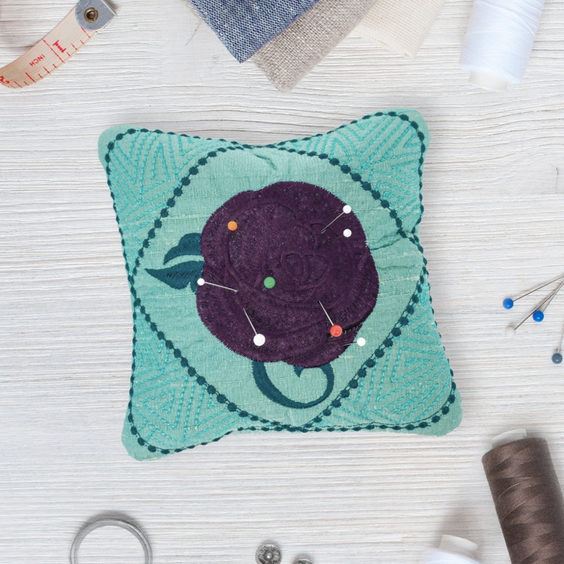

Create a one-of-a-kind elegant pincushion to keep right at your fingertips and close to your sewing station. This IQ Designer-inspired pincushion with a beautiful rose center is perfect for anyone who sews.

Created By: Denise Schober

Skill Level: Beginner

- Tools:
- Baby Lock Embroidery Machine

- Supplies:
- 6” x 10” embroidery hoop
- Madeira Thread (Decorative to coordinate)
- Baby Lock Stabilizer – No-Show Fusible Mesh (pressed to back of silk)
- 7” x 7” silk fabric
- Scrap batting to fill hoop
- Hand Sewing Needle
- Walnut shells to fill pincushion

- Instructions:

- Open IQ Designer: Click Shapes Icon. Click Square with rounded corners. Click size and resize smaller to 5.25”X5.25”. Click OK.
- Click Shapes Icon. Click Square on Point. Click Size. Resize smaller to 5.23”X5.23”. Click OK.
- Click Region Property Icon. Click Specialty Fills Icon and click select. Click #39 and click OK.
- Click Region Property fill bucket. Click inside triangle corners around the square.
- Click Line Properties Icon. Click Candlewicking Stitch. Click Yellow (3rd in second row). Click OK.
- Click Line Properties Fill Bucket. Click on the line around square. If lines are touching you will not need to do next step. Click on square on point.
- Click Next. At the top of the screen click on chain. Joining all fills together as one. Click Size and resize to 50%. Click Memory to save and click machine. Click Set.
- Click Add. Click on #2 tab. Click on design #7 and set.
- Click Edit and Rotate. Click and rotate 46 degrees to the left. Click OK.
- Click on Add and click shapes tab. Click on #2 and #10. Click on Edit and Size. Resize to 5.57”X5.57” and click OK.
- Click on Embroidery.
- Hooping: Hoop batting to fill hoop. This will be used as stabilizer and inside layer of pincushion. Silk will float on top and be basted in place. Attach hoop to machine embroidery unit. Click Layout, click baste icon. Click Layout to close the window.
- Pick colors that coordinate with the color of silk.
- Baste silk to batting. Stitch newly created design stopping at last color.
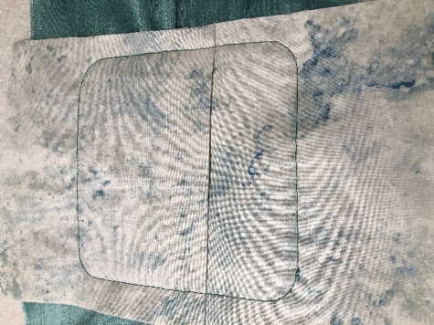

- Prepare backing: 2 pieces 6”X10” folded in half and press creating 2 pieces 6”X5”.
- Take one of the backing pieces place the fold along the center of the design. Take the second piece overlap 1” of 1st piece of backing and fold towards middle of design. You may need to tape the folds in place to keep the foot from catching. Painters tape works great for this. Thread machine with polyester sewing thread. Stitch last color.
- Remove from hoop and trim around leaving ¼” of fabric from the stitch line. Turn the right side out and press.
- Fill with crushed walnut shells. Place a small piece of batting at the opening to hold the shells in while you close the hole. Hand stitch shut and enjoy!

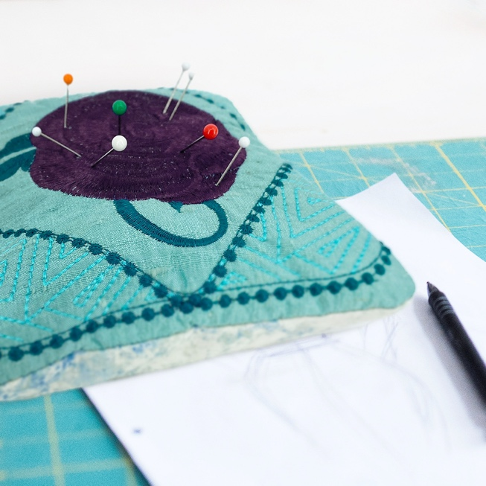

©2021 Baby Lock USA. This project may be freely used by individuals for non-commercial purposes. Project instructions may not be sold or distributed without approval from Baby Lock. Baby Lock must be acknowledged as the source of the project instructions through copyright or online link.

